**Specification: Revised Use Case / Scenarios, Personas, and Requirements**

**Scenario 1 Use Case:**

**Actors:** Student (Marty)

**Actor Goals:** Find a convenient meeting time and efficiently schedule a group meeting.

**Preconditions:** All group members have Campus Connect accounts, users have their schedules updated in the app, and users are connected as contacts within the app.

**Main Success Scenario:**

1. User opens Campus Connect app
2. User selects “Create Group Meeting” option
3. User searches and selects group members from their contacts list
4. System analyzes all selected members’ schedules
5. System displays available time slots that work for all members
6. User selects preferred time slot from available options
7. User confirms meeting details (time, duration)
8. System sends notifications to all selected group members
9. Group members receive notifications and respond with confirmation
10. System creates meeting event in all members’ schedules

**Alternative Flows:**

**4A. No common free time slots found**

* System notifies user that no common time slots are available
* System suggests alternate times with maximum member availability
* User can adjust meeting parameters or select different members

**9A. One or more members decline**

* System notifies organizer of declined responses
* System offers option to find new time slots or proceed with available members

**Scenario 2 Use Case:**

**Actors:** Primary - Student (Christina), Secondary - Student (Mark), Student (Lily)

**Actor Goals:** Quickly find and schedule study time with friends and receive notifications for study opportunities to confirm attendance.

**Preconditions:** All group members have Campus Connect accounts, users have their schedules updated in the app, users have enabled notifications, and users have shared their calendars with friends.

**Main Success Scenario:**

1. User opens the Campus Connect app.
2. System displays the user's calendar view with a weekly schedule.
3. User selects the “Friend View” option.
4. System displays overlaid schedules of selected friends.
5. System automatically identifies and displays common free time slots.
6. User selects the available time slot from the system suggestion.
7. User inputs study group details:
   1. Title: “Study Group for CS 211 exam”
   2. Location: Library
   3. Time: 4:00PM - 5:30PM
8. User confirms study group creation.
9. System sends notifications to selected friends.
10. System processes friend responses.
11. System notifies the organizer of confirmations.
12. System adds events to all participants’ calendars.

**Alternative Flows:**

**5a. No common time slots found**

* System displays the next best options with partial availability.
* Users can adjust time range or participant list.

**9a. Friend declines invite**

* System immediately notifies the organizer.
* System offers the option to find alternate time or proceed.

**Personas**

**Persona 1: Wendy - The Commuter Student**

**Goals:** Schedule quick meetups on campus without staying late.

**Frustrations:** Time spent coordinating schedules through back-and-forth texting; limited availability due to commuting constraints.

**Solution:** Campus Connect enables Wendy to see friends’ real-time availability and plan brief meetups efficiently.

**Persona 2: Marty - The Super Involved Student**

**Goals:** Efficiently coordinate study sessions and meetings without schedule conflicts.

**Frustrations:** Constant schedule conflicts with classes, clubs, and study sessions make coordination challenging.

**Solution:** Campus Connect helps Marty visualize overlapping free times among friends, streamlining scheduling.

**Requirements**

1. **Real-Time Availability Viewing:** Allow students to view friends’ schedules live to improve coordination.
2. **Personal Schedule Input:** Enable users to add their personal schedules, like classes or other commitments.
3. **Visual Overlap of Schedules:** Use a color-coded calendar view to highlight overlapping free time with friends, simplifying the scheduling of study sessions or social events.

**Revised Low-Fidelity Prototype**

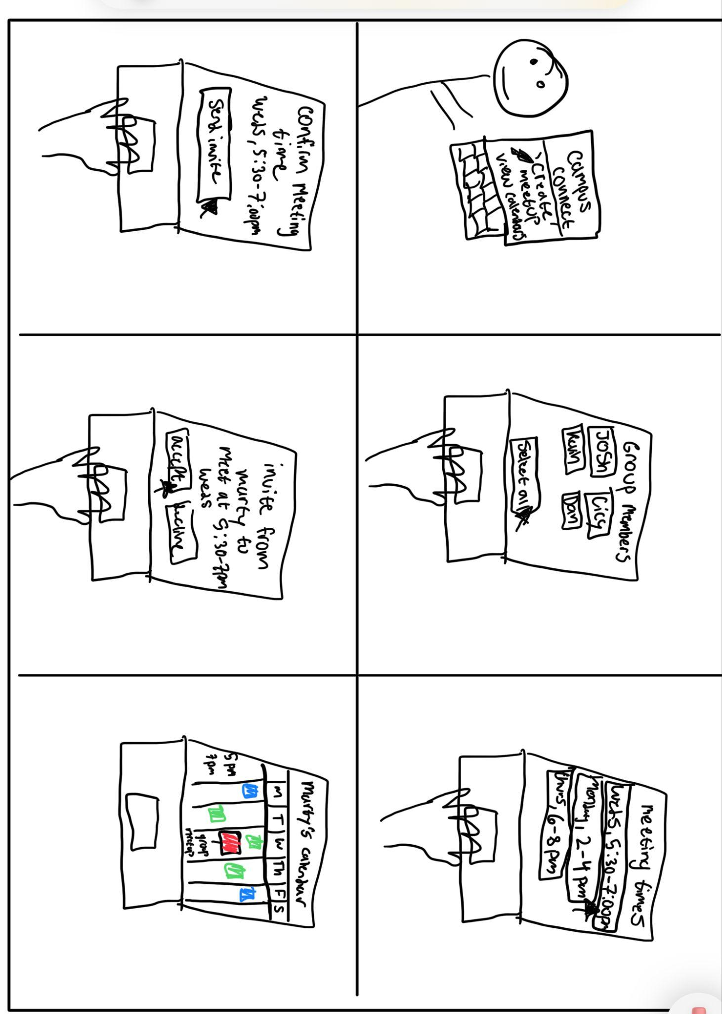**Scenario 1**

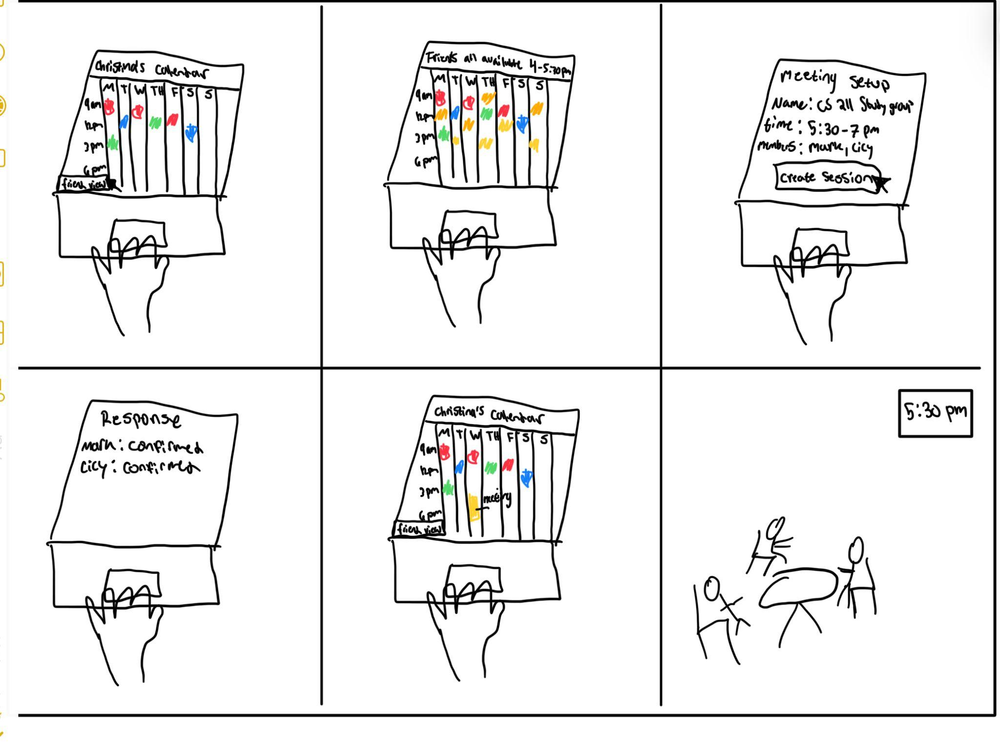**Scenario 2**

**Low-Fidelity Prototype Kit**

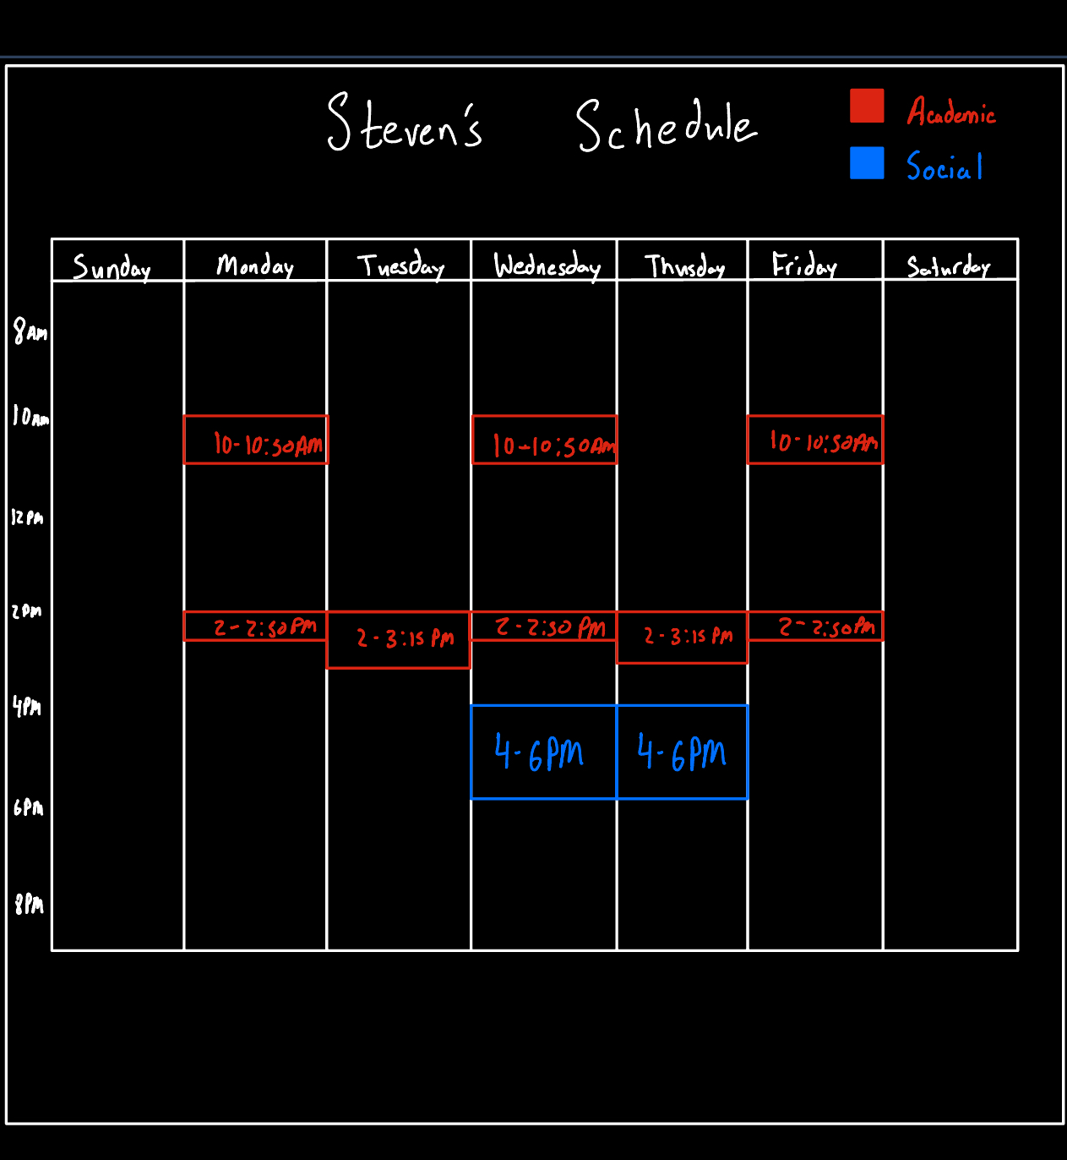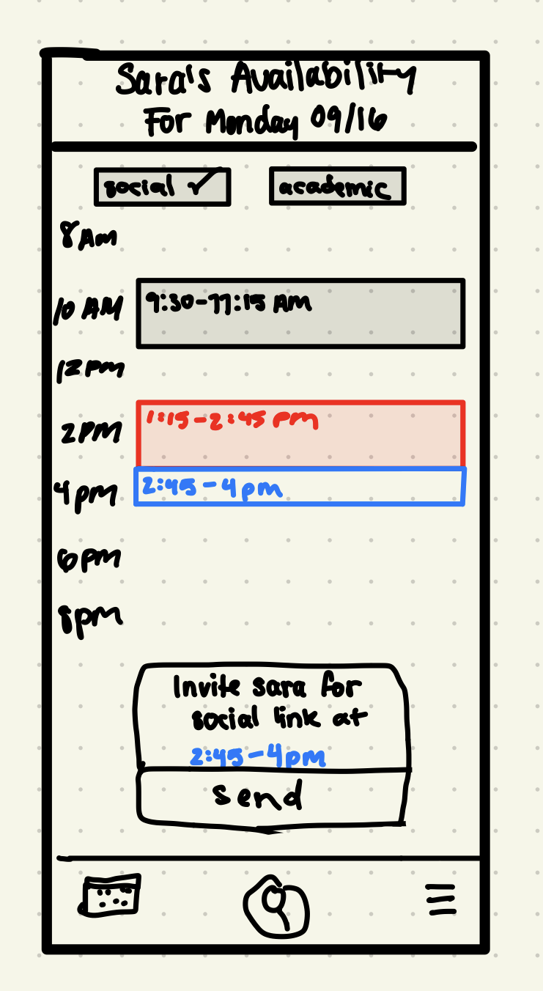

• **Materials Needed:**

• Printed mockup screens for each step in the user journey.

• Index cards and post-its for covering areas (e.g., confirmation messages, notifications).

• Scissors and markers for real-time adjustments during study sessions.

• **Preparation:** Add photos/screenshots of the kit setup and examples of screen transitions (without participant faces for confidentiality).

**Consent Form**

**Title of Study**: User Experience in Event Scheduling

**Institution**: University of Illinois at Chicago

**Contact Information**: [abern8@uic.edu](mailto:abern8@uic.edu), [sreve2@uic.edu](mailto:sreve2@uic.edu), [bdura2@uic.edu](mailto:bdura2@uic.edu), [ilina2@uic.edu](mailto:ilina2@uic.edu)

**Invitation to Participate**

You are invited to take part in a research study that explores the user experience of scheduling events with others. This form provides information about the study to help you make an informed decision about your participation.

**Study Procedures**

If you agree to participate, you will be asked to answer several questions about your experience with organizing study groups or events with fellow students. The session is expected to take around 10 minutes.

**Voluntary Participation**

Your participation is entirely voluntary. You are free to decline or withdraw from the study at any time, without any consequences.

**Confidentiality**

All responses will be kept strictly confidential and used solely for research purposes. Your data will be anonymized, and no personally identifiable information will be linked to your responses. While study results may be shared publicly, your identity will remain confidential.

**Data Security**

The data collected will be securely stored on Google Drive, accessible only to the research team.

**Questions and Contact Information**

If you have any questions regarding this study or your rights as a participant, please contact

Alex Bernatowicz - [abern8@uic.edu](mailto:abern8@uic.edu), Steven Reveles - [sreve2@uic.edu](mailto:sreve2@uic.edu), Braulio Duran - [bdura2@uic.edu](mailto:bdura2@uic.edu), or Isabella Linarez - [ilina2@uic.edu](mailto:ilina2@uic.edu)

**Consent**

By signing below, you confirm that you have read and understood the information above and voluntarily agree to participate. You also understand that you may withdraw from the study at any time.

**Participant Signature**: _________________________

**Date**: _________________________

**Question Route**

**Sample Semi-Structured Questions:**

* **Task-Based Questions:**
  + “Could you walk me through how you’d create a group study session with friends using this app?”
  + “When you view the ‘Friend View’ calendar, what information do you prioritize or look for first?”
  + “Can you show me how you would select a time slot for a group meeting with your classmates?”
* **Thought Process Questions:**
  + “What factors are you considering as you look through these free time slots for your group meeting?”
  + “How would you decide on a specific time slot when coordinating with multiple friends?”
* **Avoiding Leading Questions:**

Instead of asking, “Do you find it easy to locate an available time?”

ask,

“What would you do next if you didn’t see a suitable time slot?”

**Study / Qualitative Experience Data Gathering**

**Participant Roles:**

* **Computer:** Manages physical components of the low-fidelity prototype kit, adjusting screens and visuals based on participant interactions.
* **Facilitator:** Guides participants through the study scenarios (e.g., scheduling a study group session) and provides support without giving instructions that might bias responses.
* **Observer:** Takes detailed notes on user actions, behaviors, and comments, focusing on interactions that align with the main user needs of the app (e.g., ease of viewing friends’ availability).
* **Recorder:** Oversees audio and video equipment to ensure all participant feedback is documented for later transcription and analysis.

**Participant Demographics:**

* Confidentially record participant demographics (age, gender, and race), ensuring diversity to reflect the different types of users who might use Campus Connect.

**Session Process:**

* **Pilot Test:** Conduct a test session with mock participants (e.g., classmates or friends) to identify any issues with the kit or question route.
* **Study Adjustments:** Based on pilot results, make any necessary changes to improve the study flow, such as refining task instructions or adding clarification for scenarios.

**Findings - Data Analysis: Coding**

**Coding Framework:**

* Transcription and Unitization: Transcribe participant feedback, breaking it into sentence or phrase-length units for deeper analysis.
* Themes and Quotes: Identify and code at least four themes based on participant feedback. Suggested themes and sample quotes:
* **Theme 1:** Time Management and Efficiency
  + *Quote:* “Having a centralized schedule view saves me time instead of messaging everyone back and forth.”
* **Theme 2:** Real-Time Availability of Friends
  + *Quote:* “Seeing my friends’ free times on a single calendar is super helpful for setting up last-minute study sessions.”
* **Theme 3:** Feedback and Confirmation Notifications
  + *Quote:* “Getting a notification after scheduling made me confident that everyone got the invite.”
* **Theme 4:** Usability of Calendar Interface
  + *Quote:* “The color-coded schedule is nice; it’s easy to spot when we’re all free at a glance.”

**Implications for Design**

**Key Insights and Recommendations:**

1. **Enhanced Visual Clarity:** Use distinct and intuitive color codes to mark free, busy, and tentatively scheduled times, making it easy for users to identify mutual availability.
2. **Improved Feedback Mechanisms:** Provide clear notification confirmations immediately after scheduling events to reassure users that their actions were successful.
3. **Optimize View Transitions:** Ensure smooth, intuitive transitions between the personal calendar and “Friend View” to avoid user confusion and enhance usability.
4. **Accessibility Improvements:** Add adjustable interface elements, such as text size and calendar color contrast, to improve readability and usability for all users.

**Design Language from Readings:**

* **Interaction Design:** Follow clear mappings for button actions and transitions, ensuring that all interactions, such as selecting a time slot or sending notifications, are visible and intuitive (Rodgers, Sharp, and Preece).
* **Feedback (Norman’s Principles):** Incorporate feedback at every key interaction point, such as immediate notifications after scheduling or meeting confirmations, to provide users with confidence in the app’s responses.

**Process Explanation**

**Prototype Evolution Documentation:**

* **Initial Design:** Focused on core scheduling functions, calendar visibility, and the overlap of personal and friend schedules.
* **Feedback-Based Changes:** Added real-time notifications and modified calendar view transitions to improve usability based on user feedback.
* **Final Adjustments:** Enhanced the user interface for more responsive feedback and refined transition effects between personal and shared schedules to align with user expectations and reduce potential confusion.